NEPAL COLLEGE OF INFORMATION TECHNOLOGY
Pokhara University
LAB REPORT
Study of Digital-to-Analog Conversion: ASK, FSK, and PSK
Course | Data Communication (CMP-335)
Experiment No. | 5
Experiment Title | Study of Digital-to-Analog Conversion
Name | Suraj Kumar Jha
Roll No. | 231537
Program | B.E. Information Technology, 6th Semester

1. Objective
- To understand the concept of digital-to-analog conversion and the need to represent binary data using analog carrier signals for transmission.
- To generate and observe Amplitude Shift Keying (ASK), Frequency Shift Keying (FSK), and Phase Shift Keying (PSK) waveforms for a given binary data sequence using MATLAB.
- To compare the three modulation techniques and understand how each represents binary 1s and 0s differently.

2. Theory
Digital-to-analog conversion is the process of converting a digital (binary) signal into an analog signal so that it can be transmitted over an analog communication medium, such as a telephone line or a radio channel. This is achieved by varying one or more characteristics of a high-frequency sinusoidal carrier signal — its amplitude, frequency, or phase — according to the bits of the digital data being sent. The three fundamental digital-to-analog (or digital modulation) techniques are Amplitude Shift Keying, Frequency Shift Keying, and Phase Shift Keying.

2.1 Amplitude Shift Keying (ASK)
In Amplitude Shift Keying, the amplitude of the carrier signal is varied to represent binary data, while its frequency and phase remain constant. Typically, binary 1 is represented by transmitting the carrier signal at full amplitude, and binary 0 is represented by suppressing the carrier (zero amplitude), a scheme known as on-off keying. ASK is simple to implement but is highly sensitive to noise, since amplitude variations caused by channel noise can easily be mistaken for the signal itself.

2.2 Frequency Shift Keying (FSK)
In Frequency Shift Keying, the frequency of the carrier signal is switched between two (or more) discrete values to represent binary data, while the amplitude remains constant. In this experiment, binary 0 is represented by a lower frequency (f1 = 3 Hz) and binary 1 is represented by a higher frequency (f2 = 10 Hz). Because the amplitude of the signal does not change, FSK is more robust to amplitude noise than ASK, and is commonly used in applications such as low-speed modems and some wireless systems.

2.3 Phase Shift Keying (PSK)
In Phase Shift Keying, the phase of the carrier signal is shifted to represent binary data, while its amplitude and frequency remain constant. In this experiment, binary 1 is represented by the carrier at its original phase (0°), and binary 0 is represented by the same carrier shifted by 180° (a sign inversion). PSK provides better noise immunity than ASK and is widely used in modern digital communication systems, including many high-speed modems and satellite communication links.

2.4 Comparison of ASK, FSK, and PSK
All three techniques modulate the same underlying carrier signal but differ in which parameter (amplitude, frequency, or phase) is varied to encode the bits. ASK is the simplest to generate and detect but is the most vulnerable to noise. FSK avoids amplitude-related noise issues by encoding data in frequency, at the cost of requiring more bandwidth to accommodate the two frequencies. PSK offers the best noise performance of the three since it does not rely on detecting amplitude or frequency differences, but requires a more complex receiver capable of tracking the phase of the incoming signal.

3. Apparatus / Software Used
- MATLAB (R2023a or equivalent).
- A computer system capable of running MATLAB.

4. Signal Parameters
Parameter | Symbol | Value | Description
Carrier Frequency | fc | 5 Hz | Reference carrier / ASK & PSK 'bit 1' frequency
FSK Frequency (bit 0) | f1 | 3 Hz | Frequency used to represent binary 0
FSK Frequency (bit 1) | f2 | 10 Hz | Frequency used to represent binary 1
Binary Data Sequence | x | 1 1 0 0 1 0 1 0 | 8-bit data stream to be modulated

5. Procedure
- Define the carrier frequency (fc = 5 Hz) and the two FSK frequencies (f1 = 3 Hz for bit 0, f2 = 10 Hz for bit 1).
- Define the 8-bit binary data sequence to be transmitted: x = [1 1 0 0 1 0 1 0].
- For each bit in the sequence, generate a 1-second time segment and compute the reference carrier signal.
- If the bit is 1: set the ASK signal equal to the full-amplitude carrier, the FSK signal to a sine wave at f2, and the PSK signal to the carrier at 0° phase.
- If the bit is 0: set the ASK signal to zero (carrier suppressed), the FSK signal to a sine wave at f1, and the PSK signal to the carrier shifted by 180°.
- Plot the carrier signal, FSK, PSK, and ASK waveforms as four stacked subplots, holding each subplot across bit intervals so that the complete 8-bit waveform is built up continuously.
- Repeat the process for all 8 bits and observe the complete modulated waveforms alongside the original carrier signal.

6. MATLAB Code
close all;
clc;

f1 = 3; % Frequency representing bit 0 (FSK)
f2 = 10; % Frequency representing bit 1 (FSK)
fc = 5; % Carrier frequency

x = [1 1 0 0 1 0 1 0]; % Binary data sequence to be transmitted
nx = size(x,2);

i = 1;
while i < nx+1
t = i:0.001:i+1;
ct = sin(2*pi*fc*t); % Reference carrier signal

if x(i) == 1
ask = sin(2*pi*fc*t); % Bit 1: carrier present
fsk = sin(2*pi*f2*t); % Bit 1: higher frequency
psk = sin(2*pi*fc*t); % Bit 1: 0 degree phase
else
ask = 0; % Bit 0: carrier absent
fsk = sin(2*pi*f1*t); % Bit 0: lower frequency
psk = sin(2*pi*fc*t + pi); % Bit 0: 180 degree phase shift
end

subplot(4,1,4);
plot(t, ask); hold on; grid on;
axis([1 10 -1 1]);
title('Amplitude Shift Keying (ASK)');

subplot(4,1,2);
plot(t, fsk); hold on; grid on;
axis([1 10 -1 1]);
title('Frequency Shift Keying (FSK)');

subplot(4,1,3);
plot(t, psk); hold on; grid on;
axis([1 10 -1 1]);
title('Phase Shift Keying (PSK)');

subplot(4,1,1);
plot(t, ct); hold on; grid on;
axis([1 10 -1 1]);
title('Carrier Signal');

i = i + 1;
end

7. Results
The MATLAB program was executed for the 8-bit binary sequence x = [1 1 0 0 1 0 1 0], producing the carrier signal along with the corresponding FSK, PSK, and ASK waveforms, each plotted over a 9-second span (one second per bit).
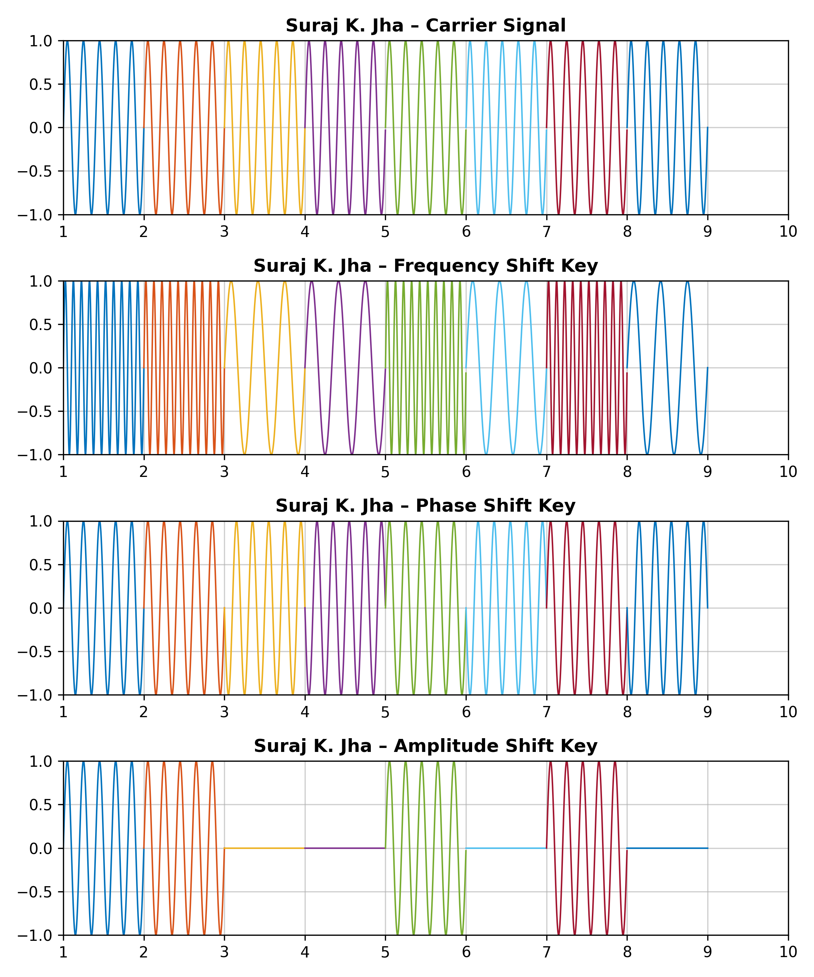
Figure 1: Carrier Signal, FSK, PSK, and ASK Waveforms for x = [1 1 0 0 1 0 1 0]

8. Discussion
The carrier signal subplot shows a continuous 5 Hz sinusoid across all 8 bit intervals, serving as the unmodulated reference. In the ASK waveform, the signal is clearly present (full amplitude) during bit intervals corresponding to 1s and completely flat (zero) during bit intervals corresponding to 0s, directly reflecting the on-off keying scheme.
In the FSK waveform, intervals corresponding to bit 1 show a visibly denser (higher-frequency, 10 Hz) waveform, while intervals corresponding to bit 0 show a sparser (lower-frequency, 3 Hz) waveform, illustrating how frequency alone is used to distinguish the two bit values. In the PSK waveform, every bit interval shows a full-amplitude 5 Hz sinusoid, but the waveform for bit-0 intervals is shifted by 180° (inverted) relative to bit-1 intervals, which is visible as a discontinuity or 'flip' in the waveform at the transitions between 1s and 0s.
These results confirm that each modulation scheme encodes the same binary sequence using a different signal parameter, and that the resulting waveforms are visually distinguishable based on amplitude presence (ASK), frequency (FSK), or phase (PSK).

9. Conclusion
In this experiment, the three fundamental digital-to-analog conversion techniques — Amplitude Shift Keying, Frequency Shift Keying, and Phase Shift Keying — were implemented and observed in MATLAB for a sample 8-bit binary sequence. Each technique was shown to successfully encode the binary data by varying a distinct property of the carrier signal, reinforcing the theoretical understanding of how digital data can be transmitted over analog communication channels.

